**Problem:**

Currently the entry, validation, and calculation of the scores generated throughout rubric portion of the competition are done manually. The amount of time spent on calculating the scores is a couple hours.

**Solution:**

Create a fully contained web application that will reduce the overall time of calculation, and simplify the entry of score data.

**Implementation:**

The application will be implemented using Ruby on Rails (RoR) and can be hosted locally or live on the web using Heroku or another RoR hosting company. The web application will have user authentication and restrict access depending on the users role: Admin or Judge. Admins will have full site access and have full CRUD (create, read, update, and delete) abilities on users and rubric data. Judges will have CRUD abilities on only rubric data. There will also be public views for guest users to view: Top 5 teams in each category (Core Values, Robot Design, and Projects), view all scores for all teams in the competition, and search by team number for their teams current statistics.

**Development Team:**

The software application will be developed by:

Christopher Cruz – Lead Software Developer

Muhammad Naviwala - Software Developer

**System Requirements (For local hosting):**

Ruby 1.9.3

Rails 3.2.13

Screen Shots:

View of the home page:

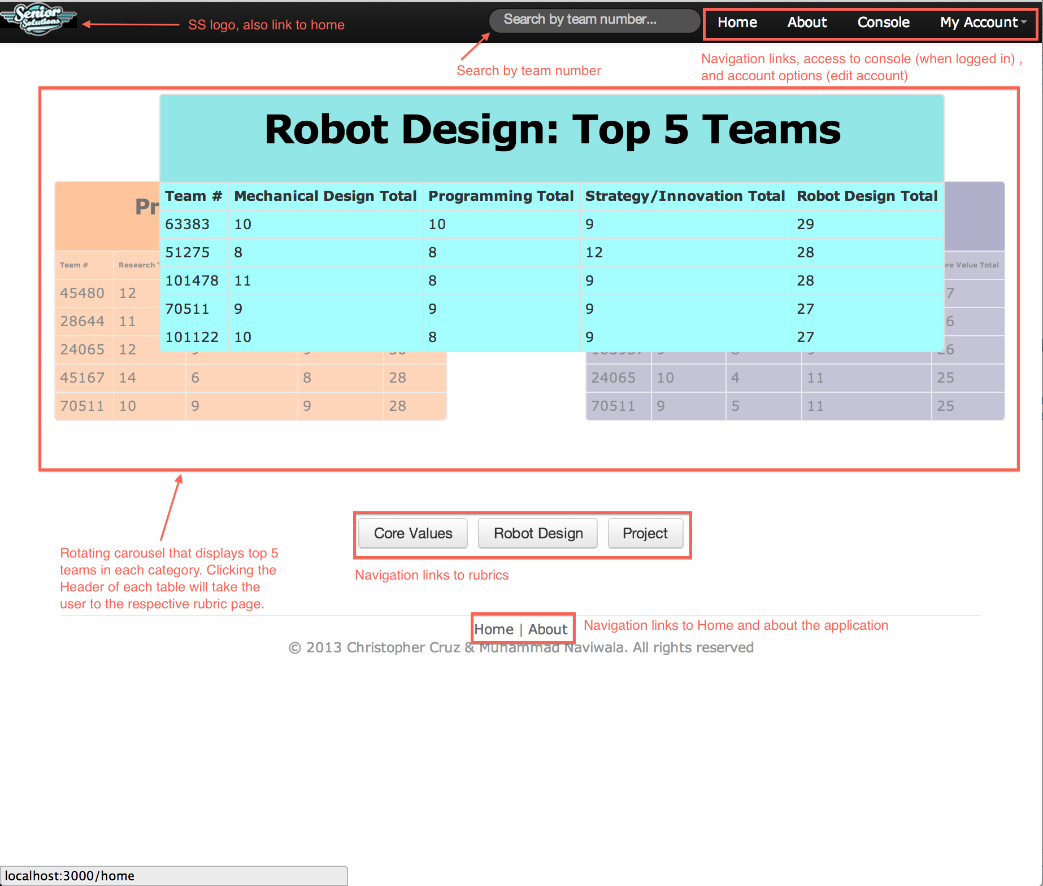

View of the Admin Console: 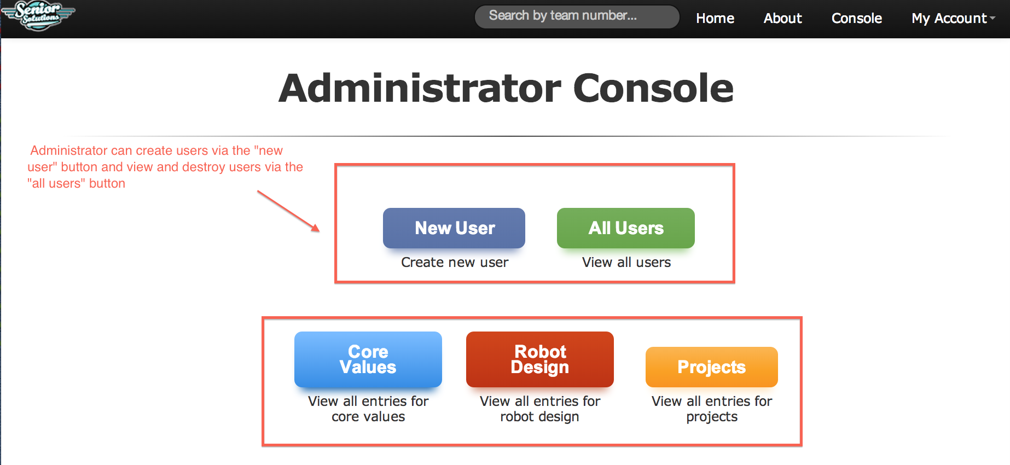

View of the Judge Console

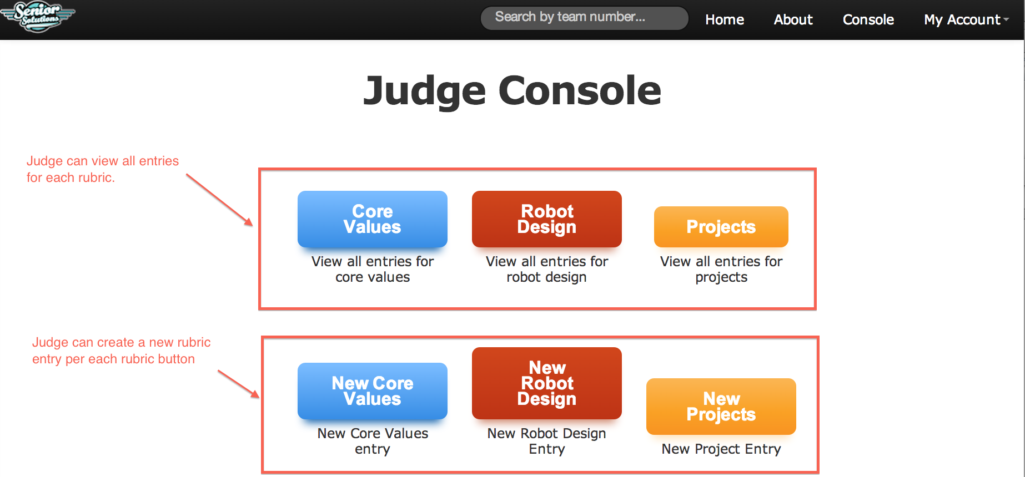

View of the rubric page (core value shown here):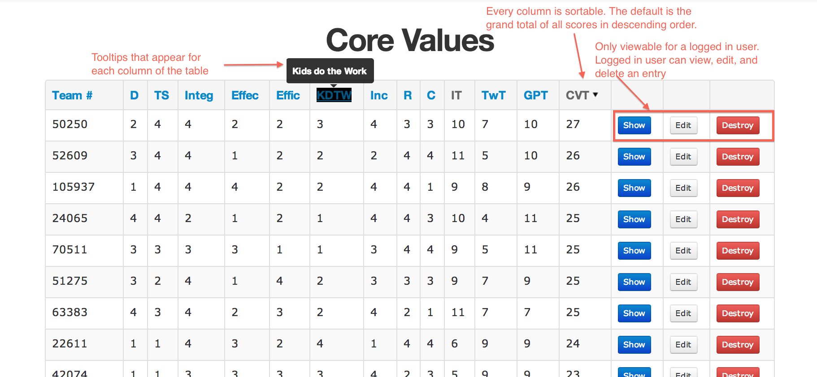

View for a rubric entry (Core value shown here):